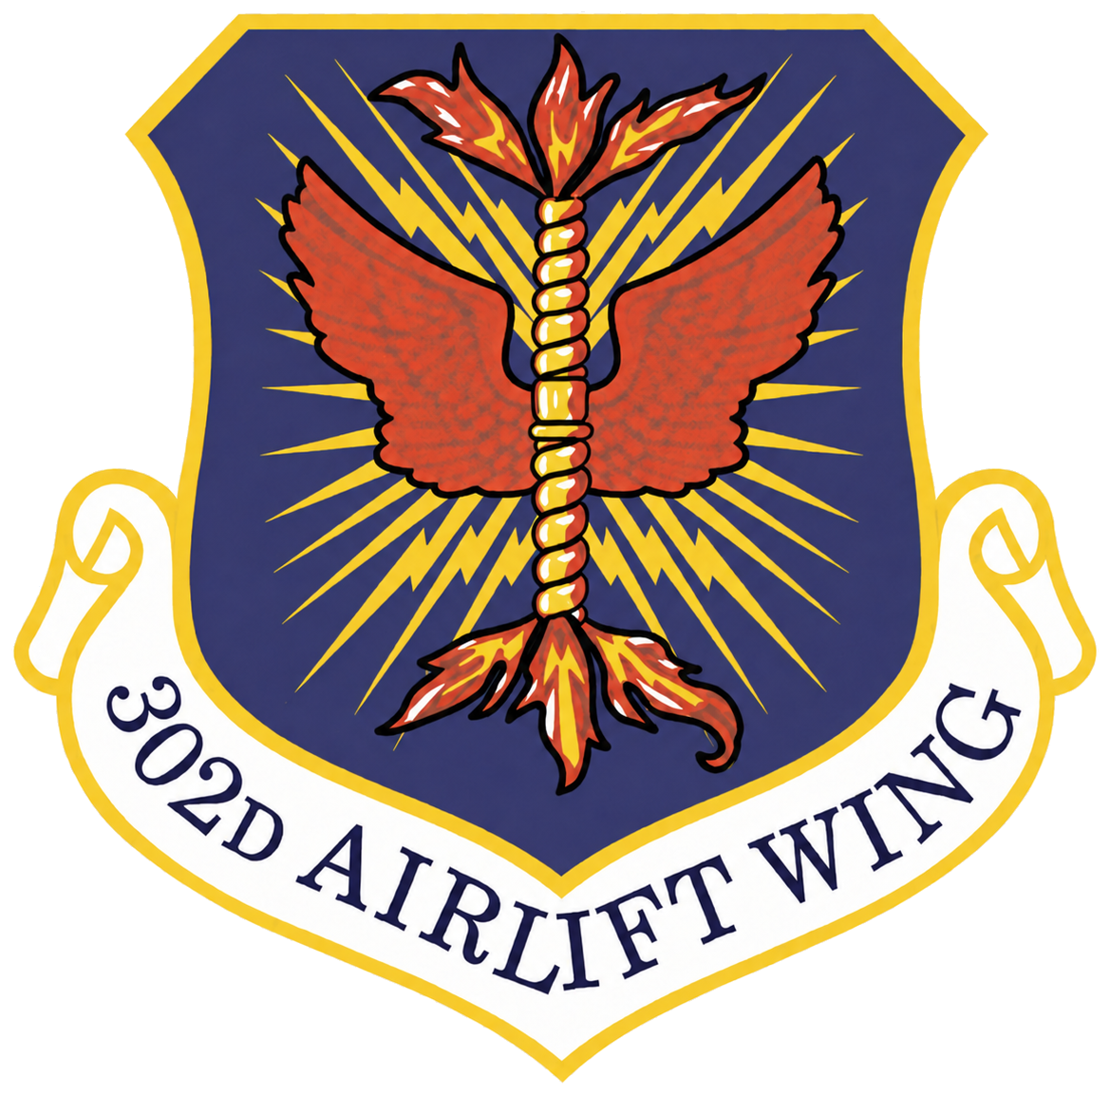
302D AIRLIFT WING
DEVELOPMENT AND TRAINING FLIGHT

Trainee Study Guide

The Importance of Being Prepared at Basic Military Training
When you arrive at BMT, you will be in a new environment which will be extremely fast paced. You will be expected to learn a lot of new information in a very short time. You can make this process much easier on yourself if you prepare as much as possible prior to leaving for BMT. In this section, you will find material which you can study which will help you to prepare. Whether you choose to learn this material or not is up to you. However, the more prepared you are, the more you will be set-up to succeed in BMT. You are highly encouraged to dedicate yourself to learning at least the following information. Your D&TF Program Manager can provide you with additional helpful information. Remember, your D&TF Program Manager is your first Air Force mentor, so reach out to him or her for help, guidance, or advice.

The Air Force Core Values
The Core Values exist for all members of the Air Force family: officer, enlisted, and civilian; active, reserve, and retired; senior, junior, and middle management; civil servants, uniformed personnel, and contractors. They are for all of us to read, to understand, to live by, and to cherish.
The Core Values are much more than minimum standards. They remind us what it takes to get the mission done. They inspire us to do our very best at all times. They are the common bond among all comrades in arms, and they are the glue that unifies the Force and ties us to the great warriors and public servants of the past.

INTEGRITY FIRST
Integrity is a character trait. It is the willingness to do what is right even when no one is looking. It is the “moral compass” the inner voice; the voice of self-control; the basis for the trust imperative in today’s military.

SERVICE BEFORE SELF
Service before self tells us that professional duties take precedence over personal desires.

EXCELLENCE IN ALL WE DO
Excellence in all we do directs us to develop a sustained passion for continuous improvement and innovation that will propel the Air Force into a long-term, upward spiral of accomplishment and performance.

Reporting Statement
You will be required to say the following statement before you begin any conversation with anyone you speak with in BMT, other than fellow trainees. You will be required to use it on the very first day at BMT. It is extremely important that you know this statement exactly as it is written below.
Sir/Ma’am, Trainee (Your Last Name) Reports As Ordered

Military Time
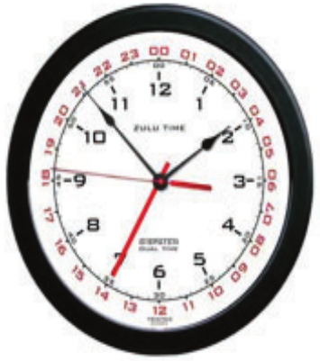 | The Air Force uses Zulu time, a 24-hour clock to identify time which helps alleviate the confusion that could be associated with an AM/PM format. Midnight is 0000hrs (Zero hundred hours). Noon is 1200hrs while 1pm is 1300hrs and so on. A specific time during an hour such as 5:31pm would be written as 1731hrs (Seventeen Thirty-one hours).

Phonetic Alphabet
A - alpha  B - bravo  C - charlie  D - delta  E - echo  F - foxtrot  G - golf  H - hotel  I - india | J - juliet  K - kilo  L - lima  M - mike  N - november  O - oscar  P - papa  Q - quebec  R - romeo | S - sierra  T - tango  U - uniform  V - victor  W - whiskey  X - x-ray  Y - yankee  Z - zulu | 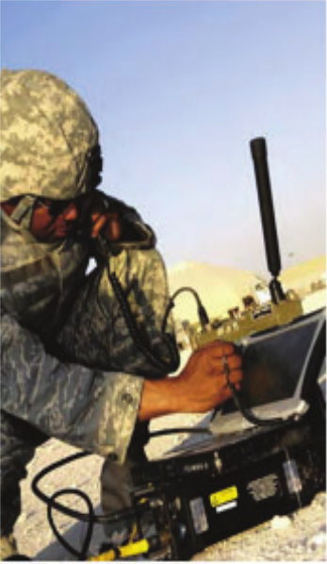

Military Rank
Military ranks are a system of hierarchical relationships. The following images show the ranks and pay grades for Air Force enlisted personnel and officers.
Take note that First Sergeant is a position, not a rank. They can be identified by the unique diamond in the chevrons. First Sergeants can be Master Sergeants, Senior Master Sergeants, or Chief Master Sergeants. A First Sergeant is the commander’s critical link within the unit for matters concerning enlisted members.
Similarly, note that Command Chief Master Sergeant is a position, not a rank. They can be identified by the unique star in the chevrons. Command Chief Master Sergeants lead the enlisted force, and advise commanders on matters that affect the enlisted force.
There is only one Chief Master Sergeant of the Air Force at any time, and he or she is the highest ranking enlisted person in the Air Force. The Chief Master Sergeant of the Air Force can be identified by the wreaths around the lower star and Great Seal of the United States (eagle) with two stars in the chevrons.
Enlisted Ranks  Insignias and Pay Grades |  | Officer Ranks  Insignias and Pay Grades
E-1  Airman Basic | No Insignia | O-1  Gold Bar  2nd Lieutenant | 
E-2  Chevron of one stripe  Airman |  | O-2  Silver Bar  1st Lieutenant | 
E-3  Chevron of two stripes  Airman First Class |  | O-3  Two Silver Bars Connected  Captain | 
E-4  Chevron of three stripes  Senior Airman |  | O-4  Gold Oak Leaf  Major | 
E-5  Chevron of four stripes  Staff Sergeant |  | O-5  Silver Oak Leaf  Lieutenant Colonel | 
E-6  Chevron of five stripes  Technical Sergeant |  | O-6  Silver Eagle  Colonel | 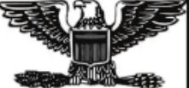
E-7*  Chevron of six stripes.  One of which is inverted  Master Sergeant |  | O-7  One Silver Star  Brigadier General | 
E-8*  Chevron of seven stripes.  Two of which is inverted  Senior Master Sergeant |  | O-8  Two Silver Stars in line  Major General | 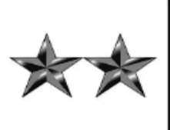
E-9*  Chevron of eight stripes.  Three of which is inverted  Chief Master Sergeant | 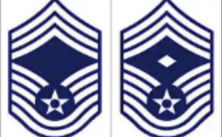 | O-9  Three Silver Stars in line  Lietenant General | 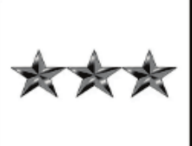
E-9  (Special Positions)  **CCM  ***CMSgt of the Air Force |  | O-10  Four Silver Stars in line  General | 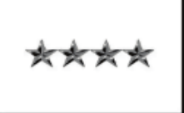
*First Sergeant: Denoted by the rank insignia of a MSgt, SMSgt, or CMSgt with a diamond in the upper field.
**Command Chief Master Sergeant. A chevron of eight Stripes, three of which are inverted with a star in the center, and a second star above the first.
***Chief Master Sergeant of the Air Force: A chevron of eight stripes, three of which are inverted with a star surrounded by a wreath in the center, and the Great Seal of the United States flanked by two stars

Common Acronyms and Abbreviations
Use this quick reference to understand terms you will hear during drill weekends, training, and routine military business.

Reserve Service and Training
AFR / AFRC — Air Force Reserve / Air Force Reserve Command.
D&TF / DTF — Development and Training Flight; preparation before Basic Military Training.
UTA — Unit Training Assembly; a scheduled unit drill period, commonly called drill weekend.
IDT — Inactive Duty Training; a duty category that includes regularly scheduled drills.
AT — Annual Training; also called annual tour in Reserve usage.
TR / AGR / ART — Traditional Reservist / Active Guard Reserve / Air Reserve Technician; different Reserve service categories.
BMT / MTI — Basic Military Training / Military Training Instructor.
AFSC — Air Force Specialty Code; the code identifying your military career specialty.
OJT / CBT — On-the-Job Training / Computer-Based Training.
PT / PME — Physical Training / Professional Military Education.

Administration Pay and Travel
CAC — Common Access Card; your military identification and computer-access card.
DEERS — Defense Enrollment Eligibility Reporting System; your military benefits eligibility record.
LES — Leave and Earnings Statement; the statement showing your military pay and deductions.
DFAS — Defense Finance and Accounting Service; the agency that processes military pay.
myPay — DFAS online service for pay statements, tax documents, and pay-account updates.
FSS / MPF — Force Support Squadron / Military Personnel Flight; organizations that support personnel services.
CSS — Commander’s Support Staff; your unit’s administrative support office.
vMPF — Virtual Military Personnel Flight; an online personnel self-service system.
DTS — Defense Travel System; used for official travel authorizations and vouchers.
GTCC — Government Travel Charge Card; the card used for authorized official travel expenses.
TDY / PCS — Temporary Duty / Permanent Change of Station; temporary travel versus a permanent duty-station move.
AROWS-R — Air Force Reserve Order Writing System; the system used to produce Reserve orders.
FY — Fiscal Year; the federal budget year runs from 1 October through 30 September.

Ranks and Leadership
AB / Amn / A1C / SrA — Airman Basic (E-1) / Airman (E-2) / Airman First Class (E-3) / Senior Airman (E-4).
SSgt / TSgt — Staff Sergeant (E-5) / Technical Sergeant (E-6).
MSgt / SMSgt / CMSgt — Master Sergeant (E-7) / Senior Master Sergeant (E-8) / Chief Master Sergeant (E-9).
2d Lt / 1st Lt / Capt — Second Lieutenant (O-1) / First Lieutenant (O-2) / Captain (O-3).
Maj / Lt Col / Col — Major (O-4) / Lieutenant Colonel (O-5) / Colonel (O-6).
Brig Gen / Maj Gen — Brigadier General (O-7) / Major General (O-8).
Lt Gen / Gen — Lieutenant General (O-9) / General (O-10).
NCO / SNCO — Noncommissioned Officer / Senior Noncommissioned Officer. In the Air Force, SSgt and TSgt are the NCO tier; MSgt through CMSgt are the SNCO tier.
CC / SEL — Commander / Senior Enlisted Leader; leadership positions, not ranks.
CSAF / CMSAF — Chief of Staff of the Air Force / Chief Master Sergeant of the Air Force.

Everyday Communication
POC — Point of Contact; the person to contact about a particular subject.
NCOIC / OIC — Noncommissioned Officer in Charge / Officer in Charge.
NLT / COB — No Later Than / Close of Business; terms used to communicate deadlines.
SOP — Standard Operating Procedure; written instructions for a routine task or process.
AFI / DAFI — Air Force Instruction / Department of the Air Force Instruction; official written guidance.



THE U.S. AIR FORCE SONG
Off we go into the wild blue yonder,
Climbing high into the sun.
Here they come, zooming to meet our thunder,
At ’em now, give’em the gun!
Down we dive, spouting our flame from under,
Off with one helluva roar!
We live in fame or go down in flame. Hey!
Nothing’ll stop the US Air Force!

THE AIRMAN’S CREED
I am an American Airman.
I am a warrior.
I have answered my nation’s call.
I am an American Airman.
My mission is to fly, fight, and win.
I am faithful to a proud heritage;
a tradition of honor,
and a legacy of valor.
I am an American Airman,
guardian of freedom and justice,
my nation’s sword and shield,
its sentry and avenger.
I defend my country with my life.
I am an American Airman:
wingman, leader, warrior.
I will never leave an Airman behind,
I will never falter,
and I will not fail.

CHAIN OF COMMAND
President of the United States | Donald Trump | Civilian
Vice President of the United States | JD Vance | Civilian
Secretary of Defense (SECDEF) | Pete Hegseth | Civilian
Secretary of the Air Force (SECAF) | Dr. Troy Meink | Civilian
Chief of Staff of the Air Force (CSAF) | Gen Kenneth S. Wilsbach | O-10
Chief Master Sergeant of the Air Force (CMSAF) | CMSgt David R. Wolfe | E-9
Commander of the Air Force Reserve | Lt Gen Paul R. Fast | O-9
Command Chief Master Sergeant of the Air Force Reserve | CMSgt Israel Nunez | E-9
Commander, Twenty-Second Air Force | Maj Gen Frank Bradfield III | O-8
Command Chief Master Sergeant, Twenty-Second Air Force | CMSgt Brian R. Jensenius | E-9
Commander, 302d Airlift Wing | Col Elissa D. Granderson | O-6
Command Chief Master Sergeant, 302d Airlift Wing | CMSgt Andrea L. Estes | E-9
D&TF Coordinator | TSgt Jared Wells | E-6

Drill Positions & Facing Movements
Drill consists of certain positions and movements by which the element or flight is moved in an orderly manner from one formation to another or from one place to another.
Everyone in the formation must move together on command. A drill command is an oral order. Most drill commands have two parts, the preparatory command and the command of execution, for example: FLIGHT, ATTENTION. In certain commands, the preparatory command and the command of execution are combined, for example: FALL IN, AT EASE, and REST. Execute facing movements from a halt, at the position of attention, and in the cadence of quick time. Perform facing movements in two counts.
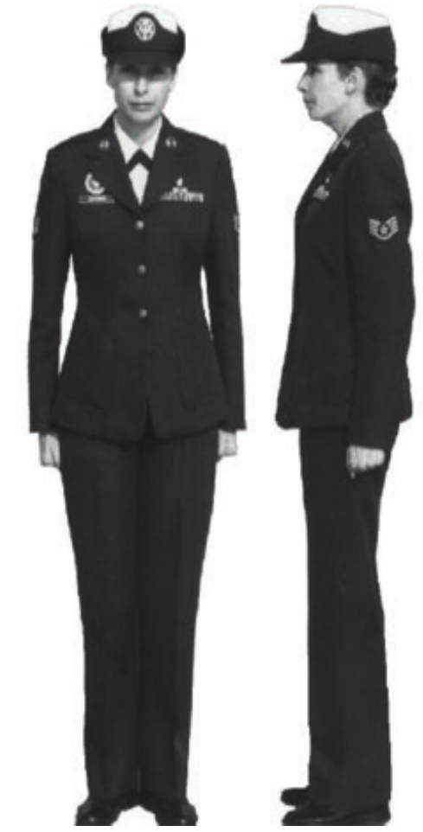 | 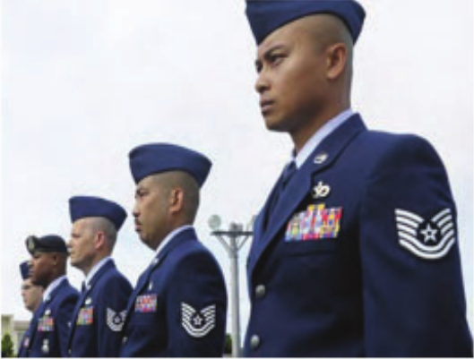  Position of Attention  To come to attention, bring the heels together smartly and on line. Place the heels as near each other as the conformation of the body permits, and ensure the feet are turned out equally, forming a 45-degree angle. Keep the legs straight without stiffening or locking the knees. The body is erect with hips level, chest lifted, back arched, and shoulders square and even. Arms hang straight down alongside the body without stiffness, and the wrists are straight with the forearms.  Place thumbs, which are resting along the first joint of the forefinger, along the seams of the trousers or sides of the skirt. Hands are cupped (but not clenched as a fist) with palms facing the leg (figure 1). The head is kept erect and held straight to the front with the chin drawn in slightly so the axis of the head and neck is vertical; eyes are to the front, with the line of sight parallel to the ground. The weight of the body rests equally on the heels and balls of both feet, and silence and immobility are required.
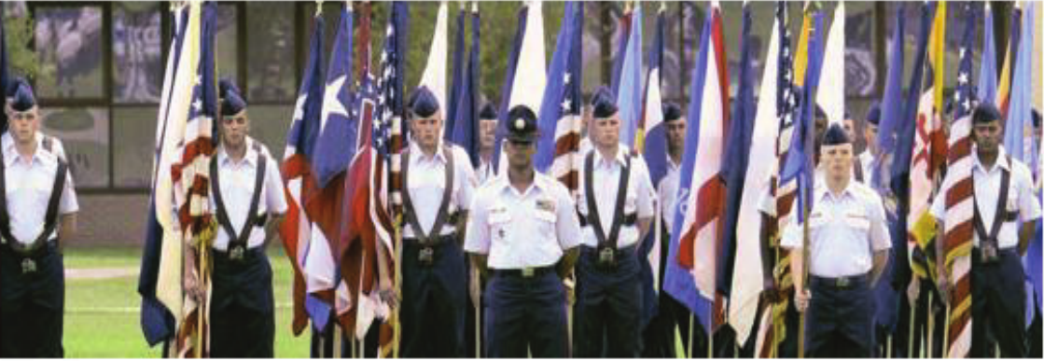
Parade Rest  The command is PARADE, REST. On the command REST, the airman will raise the left foot from the hip just enough to clear the ground and move it smartly to the left so the heels are 12 inches apart, as measured from the inside of the heels. Keep the legs straight, but not stiff, and the heels on line. As the left foot moves, bring the arms, fully extended, to the back of the body, uncupping the hands in the process; and extend and join the fingers, pointing them toward the ground. The palms will face outwards. Place the right hand in the palm of the left, right thumb over the left to form an “X” (figure 2). Keep head and eyes straight ahead and remain silent and immobile.  At Ease  The command is AT EASE. On the command AT EASE, airmen may relax in a standing position, but they must keep the right foot in place. Their position in the formation will not change, and silence will be maintained.  Rest  The command is REST. On the command REST, the same requirements for AT EASE apply, but moderate speech is permitted.  Fall Out  The command is FALL OUT. On the command FALL OUT, individuals may relax in a standing position or break ranks. They must remain in the immediate area, and no specific method of dispersal is required. Moderate speech is permitted. | 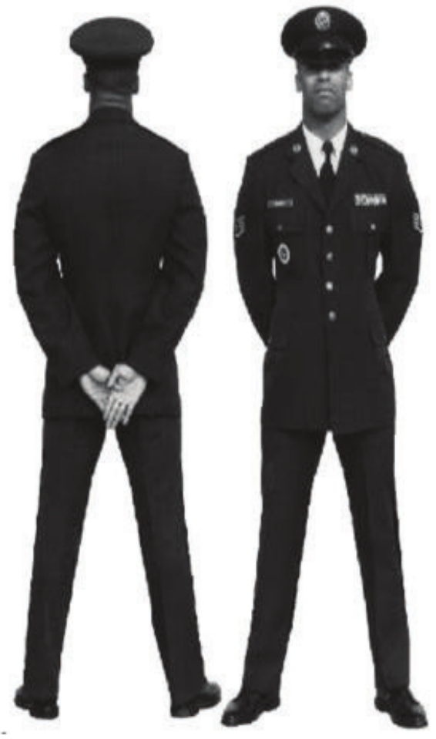

Common Marching Commands
Learn each command and practice the response until you can perform it with the flight. Prepare when you hear the preparatory command; execute together when you hear the command of execution.

Preparatory and Execution Commands
The preparatory command tells you what is coming; the command of execution tells you when to act. In Forward, MARCH, Forward is preparatory and MARCH starts the movement. Memorize the pairs below, but listen to the full command: Flight can introduce HALT or ATTENTION. COVER is a single command; no second word follows.

Flight Attention
Flight → ATTENTION. From a rest position other than fall out, assume parade rest on Flight. On ATTENTION, bring your heels together and return to the position of attention. Remain silent and still.

At Ease
AT EASE — act on the combined command. Relax while standing, but keep your right foot in place. Maintain your position in the formation and remain silent.

Fall Out
FALL OUT — act on the combined command. You may relax while standing or break ranks. Remain in the immediate area; moderate speech is permitted. No specific method of dispersal is required.

Forward March
Forward → MARCH. From attention, step forward with your left foot. Use 24-inch steps, coordinated arm swing, and the flight’s cadence.

Flight Halt
Flight → HALT. While marching, take one more step, then bring the trailing foot alongside the leading foot and stop at attention.

Cover
COVER — act on the single command. Use short, choppy steps to recover proper flight position. In column, align behind the person ahead and beside the person to your right; restore spacing. The guide remains in place.

Left Face
Left → FACE. From attention, pivot 90 degrees left on your left heel and right forefoot; bring the right foot alongside the left.

Right Face
Right → FACE. From attention, pivot 90 degrees right on your right heel and left forefoot; bring the left foot alongside the right.

About Face
About → FACE. From attention, place your right forefoot half a shoe length behind and slightly left of your left heel. Pivot 180 degrees right on those contact points, finishing at attention.
Practice facing movements while halted, in two counts, keeping your upper body at attention.
Reference: DAFPAM 34-1203, Drill and Ceremonies, 13 September 2022, paragraphs 2.1, 3.2, 3.3, 3.4, 3.10, and 4.4.2.

Air Force Reserve Command Structure
From smaller working units to larger commands, each level supports the mission of the organization above it. This is a general guide; unit structures can vary.
Team — A small group working on a shared task, often within a flight or section. It is not always a formal command level.
Flight — A unit or subdivision that performs a specific function, usually within a squadron.
Squadron — A basic Air Force unit that carries out a defined mission, often organized into flights.
Group — Usually combines squadrons with related missions, such as operations or maintenance.
Wing — Brings together groups and other units to accomplish a broader mission, such as the 302d Airlift Wing.
Numbered Air Force — An intermediate command that oversees assigned wings and other units within AFRC.
Major Command — A major subdivision of the Air Force. Air Force Reserve Command (AFRC) is our major command, or MAJCOM.
Remember the order: Team → Flight → Squadron → Group → Wing → Numbered Air Force → Major Command
References: Air Force Historical Research Agency, Types of USAF Organizations; U.S. Air Force, Air Force Reserve Command fact sheet.

